***Virginia Junior Classical League***

*presents this*

Certificate of Excellence

*to*

Jean Paul Staelens de Pomar

*of*

River Bend Middle School

*for*

*1st Place in Costume - Boys Lower Division*

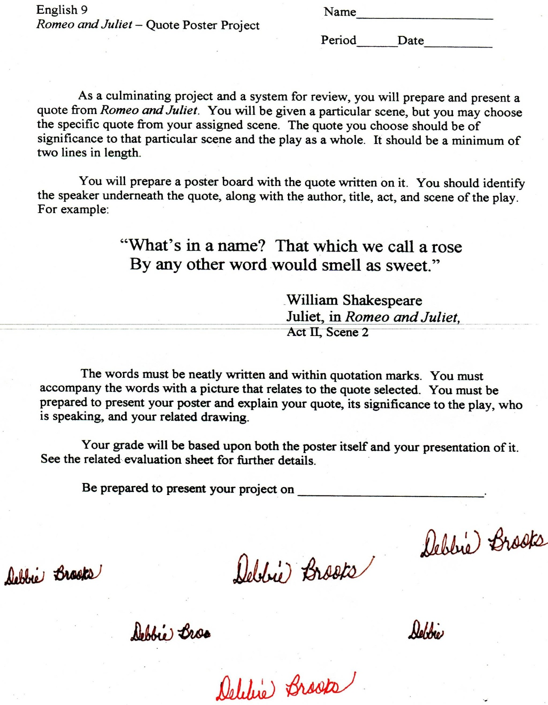

Microsoft Office Signature Line...

*a.d. viii Kal. Dec. MMDCCLXVII A.U.C. 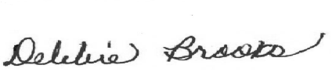*

***Virginia Junior Classical League***

*presents this*

Certificate of Excellence

*to*

Jean Paul Staelens de Pomar

*of*

River Bend Middle School

*for*

*2nd Place in Small Models*

**

Microsoft Office Signature Line...

*a.d. viii Kal. Dec. MMDCCLXVII A.U.C. *

***Virginia Junior Classical League***

*presents this*

Certificate of Excellence

*to*

Jean Paul Staelens de Pomar

*of*

River Bend Middle School

*for*

*3rd Place in Reading Comprehension*

**

Microsoft Office Signature Line...

*a.d. viii Kal. Dec. MMDCCLXVII A.U.C. *

***Virginia Junior Classical League***

*presents this*

Certificate of Excellence

*to*

Jean Paul Staelens de Pomar

*of*

River Bend Middle School

*for*

*4th Place in Grammar*

**

Microsoft Office Signature Line...

*a.d. viii Kal. Dec. MMDCCLXVII A.U.C. *

***Virginia Junior Classical League***

*presents this*

Certificate of Excellence

*to*

Caroline Rippey

*of*

River Bend Middle School

*for*

*5th Place in Maps*

**

Microsoft Office Signature Line...

*a.d. viii Kal. Dec. MMDCCLXVII A.U.C. *

***Virginia Junior Classical League***

*presents this*

Certificate of Excellence

*to*

Kiersten Lemke

*of*

River Bend Middle School

*for*

*6th Place in Reading Comprehension*

**

Microsoft Office Signature Line...

*a.d. viii Kal. Dec. MMDCCLXVII A.U.C. *

***Virginia Junior Classical League***

*presents this*

Certificate of Excellence

*to*

Kiersten Lemke

*of*

River Bend Middle School

*for*

*7th Place in Grammar*

**

Microsoft Office Signature Line...

*a.d. viii Kal. Dec. MMDCCLXVII A.U.C. *

***Virginia Junior Classical League***

*presents this*

Certificate of Excellence

*to*

Caroline Rippey

*of*

River Bend Middle School

*for*

*7th Place in Modern Myth*

**

Microsoft Office Signature Line...

*a.d. viii Kal. Dec. MMDCCLXVII A.U.C. *

***Virginia Junior Classical League***

*presents this*

Certificate of Excellence

*to*

Caroline Rippey

*of*

River Bend Middle School

*for*

*7th Place in Reading Comprehension*

**

Microsoft Office Signature Line...

*a.d. viii Kal. Dec. MMDCCLXVII A.U.C. *